**CHAPTER ONE**

**INTRODUCTION**

**1.0 Preamble**

This chapter discuss the background of the study, Problem statement, Aim and objectives of the study, Motivation, Scope and Limitation of the study, Significance of the Study as well as Project Organization.

**1.1 Background of the Study**

The majority of road users usually face a vehicle breakdown when traveling on the major roads. These road users usually look for an automobile mechanic, and mechanic usually try to locate a spare parts store. Sometimes travelers have to find other means to transport themselves. A lot of people are facing difficulties getting help when their car breaks down on the road. Many of them do not have any Car Repair Service Providers’ contact numbers and could not get help as the Car Repair Service Providers might be far away from their locations. These problems are the motivations for the development of this project to help those who are in need when their car breaks down along the roads. During the holiday seasons, cases of car breakdowns increase more as long trips put vehicles at greater risk of breakdown. In case of a breakdown in the state route and the route in the city, it can be difficult to get help if the driver is not familiar with that place. When it comes to breakdowns in rural areas, it could be worse since the breakdown point is far from the car repair service providers (Surekha, 2021).

A Geographic Information System (GIS) is a computer-based information system for storing, managing and analyzing, and invoking geographic reference data that has developed rapidly in the last five years, GIS is a computer system that captures, stores, validates and displays data about locations on the Earth's surface. GIS can display a wide range of data on a single map, including streets, buildings, and plants. This allows people to quickly identify, evaluate, and comprehend patterns and correlations. the aim of this project is to aid in simplifying the process of finding the nearest mechanic through media mapping (Wibowo, 2018).

Traveling is a delightful experience that everyone has experienced so we plan ahead but due to unforeseen situations there may be complications to our vehicles the application will use the user's current location to decide the nearest mechanic workshop or garage available and display all the remaining mechanic shops in ascending order of the distance from the user. When we take the situation of Vehicle breakdown there are different aspects that can cause problems that lead to injuries and fatalities (Surekha, 2021).

Geo-Locators give accurate information about the nearest garage or workshop facilities around a particular area, allowing users to reduce the time required to search the mechanic garage once the incident happens. This application helps you to find your nearby service centers, and exact locations with the distance from your place the directions using Google Maps let you know with ease to access with the help of this application on your smart mobile.

This highlights the need for a mobile-based solution that will ease the difficulties in locating nearby mechanics and garages when faced with unexpected vehicle breakdowns. Such an application, utilizing Geographic Information System (GIS) technology, can provide users with real-time information about the nearest service centers, their exact locations, and the distances from the user's current position. With the convenience of directions using Google Maps, travelers can swiftly and efficiently access assistance when their vehicles encounter issues during their journeys. This innovative solution addresses the challenges that road users often encounter, especially during holiday seasons or in unfamiliar locations, making it a valuable tool for enhancing road safety and the overall travel experience.

The proposed system will provide the system with the highest level of user-friendliness through efficiency, accuracy, availability, and reliability that can be achieved through system performance.

**1.2 Problem statement**

The problem while traveling is a breakdown of our vehicle. In the existing system, there are users who have their own mechanic contact details and it is also difficult for them to arrive in time or might not be close to the area of breakdown at that time. The only way is to look for any other transportation at that time of incidence and then they need to get a mechanic to the particular location at which they have left their vehicle, although the safety of their vehicles is not guaranteed. In this application, the users can get nearby area mechanics by searching at anytime and anywhere.

The above problems highlight the need for the development of a mobile-based vehicle breakdown assistant system

**1.3 Aim and objectives of the study**

The aim of this project to design and develop a mobile-based vehicle breakdown assistant system and the objectives are:

1. To analyse the requirement of the system
2. To develop the system
3. To evaluate the system

**1.4 Motivation**

My motivation lies in leveraging these technological advancements to create a safer and more efficient road travel experience for all.

**1.5 Significance of the Study**

The system stands for Road Vehicle Breakdown Assistance and is a way for every driver to find a solution for his/ her car whenever a breakdown occurs while on a journey, it helps them to reduce stress in finding a mechanic in the area there don’t know much about with this app it makes things goes easy for them.

1. The Drivers: to request for any nearby mechanics' assistance when their car has a fault.
2. The Mechanics: accept or reject requests from drivers and render them their services.

**1.6 Project Organization**

Project organization refers to how the chapters in a project are structured and basically what is contained in them. The project is divided into five chapters. The outlines are presented below:

**Chapter One: Introduction**

Chapter one introduces this project work, the background of the study, the statement of the problem, the aim and objectives, the scope of the study, limitations of the study, the significance of the study, project organization, and the definition of terms.

**Chapter Two: Literature review**

This chapter focuses on the literature review, and the contributions of other scholars on the subject matter being discussed.

**Chapter Three: Methodology and Design**

This chapter is concerned with the presentation of the end results of system analysis and design. It presents the research methodology used in the development of the system to facilitate an understanding and effective future implementation of the system.

**Chapter Four: System Implementation Evaluation**

This chapter describes the system implementation and documentation, analysis of modules, and system requirements for implementation.

**Chapter Five: Summary, Conclusion, and** **Recommendation**

The chapter provides a summary of major findings, conclusions, and recommendations based on the study conducted.

**1.8 Definition of Terms**

1. **Google Map**: A web-based mapping service called Google Maps was created by Google. It enables route planning for travel by foot, automobile, bicycle, or public transit as well as satellite images, street maps, 360-degree panoramic views of streets, and current traffic conditions.
2. **Database**: A database is a collection of arranged data that is electronically stored and accessible. A database often contains significant volumes of structured data that can be searched, sorted, and retrieved with ease by users.
3. **Django**: Django is a free and open-source web framework written in Python. It is designed to make the development of complex, database-driven websites and applications easier and more efficient.
4. **GIS**: Geographic information system is referred to as GIS. It is a system for gathering, conserving, processing, and managing geographic or geographical data. Users of GIS may produce and examine maps as well as analyze and comprehend geographical data.
5. **REST:** REST, or Representational State Transfer, is an architectural style for building web services and APIs. It is a set of principles and guidelines that define how a web service or API should be structured and how it should operate.
6. **API**: An API, or application programming interface, is a set of rules and protocols that allows different software applications to communicate with each other. An API defines the way in which different software components should interact and exchange data, allowing them to work together to accomplish a specific task or function.
7. **Flutter**: Flutter is a free and open-source mobile application development framework created by Google. It is used to build natively compiled applications for mobile, web, and desktop from a single codebase.
8. **UI**: UI stands for the user interface. It is the part of an application or website that the user interacts with directly. The user interface is the means by which the user and the application or website communicate with each other.

**CHAPTER TWO**

**LITERATURE REVIEW**

**2.0 Preamble**

This chapter discuss Information management system, Mobile based system, Assistance system, Review of related past works, Summary of related literature reviews, Analysis of the current system, Problem inherent in the current system as well as advantages of the new proposed system.

**2.1 Information Management System**

An essential component of this project is the implementation of an Information Management System (IMS). IMS is a structured approach to collecting, storing, organizing, and retrieving data and information efficiently. In the context of this project, the IMS plays a pivotal role in managing various types of information related to vehicle breakdowns, service providers, and user interactions. The IMS ensures the systematic storage and retrieval of critical data such as user profiles, mechanic and garage details, geographical coordinates, and service history. It allows for seamless integration with Geographic Information System (GIS) technology, enabling the application to provide real-time, location-based services. (Wibowo, 2018)

Moreover, the IMS assists in tracking and managing user inquiries, feedback, and service requests. It contributes to a seamless user experience by ensuring that users can easily access relevant information, such as the nearest available mechanics and service centers, while also streamlining the process of requesting assistance. To support these functionalities, the IMS is equipped with robust security measures to protect user data and privacy. Authentication and authorization mechanisms are implemented to ensure that only authorized personnel can access and modify sensitive information. (Wibowo, 2018)

This incorporation of an Information Management System (IMS) aligns with the project's objective of leveraging technological advancements and Geographic Information System (GIS) tools to streamline the process of locating and accessing vehicle repair services. It underscores the significance of efficient data management in providing users with quick and reliable solutions during unforeseen vehicle breakdowns. (Surekha, 2021)

**2.2 Mobile Based System**

In the modern digital era, mobile devices have become an integral part of our daily lives, offering convenience and accessibility like never before. This project is built upon the premise of harnessing the ubiquity and power of mobile technology to deliver essential services to users. A mobile-based system serves as the core of this initiative, enabling road users to access critical information and services at their fingertips. Leveraging the popularity of smartphones, the system provides a user-friendly interface that empowers individuals to quickly and efficiently locate nearby mechanics and garages when faced with vehicle breakdowns. (Nadeeshani, 2020)

The mobile application not only offers ease of access but also leverages the capabilities of GPS and location-based services. By utilizing Geographic Information System (GIS) technology, the application can pinpoint the user's exact location and display a list of the nearest service providers. Users can effortlessly navigate through maps and directions, making it simpler than ever to reach assistance swiftly. Furthermore, the mobile-based system promotes real-time communication and information exchange. Users can report breakdowns, request assistance, and provide feedback directly through the application. This seamless interaction enhances user experience and ensures that help is just a few taps away. (Nadeeshani, 2020)

In addition to serving road users, the mobile-based system benefits service providers by providing them with a digital platform to showcase their services, availability, and contact information. This not only expands their reach but also fosters transparency and trust within the community.

The integration of a mobile-based system reflects the project's commitment to embracing contemporary technological advancements. It is a testament to the transformative potential of mobile technology in addressing real-world challenges and enhancing the safety and convenience of road travel. (Nadeeshani, 2020)

**2.3 Assistance System**

The Assistance System is the core element of this project, designed to provide swift and efficient aid to road users facing vehicle breakdowns. It encompasses a range of features and functionalities aimed at enhancing user experience and ensuring timely assistance.

Key components of the Assistance System include:

1. Mobile Application: A user-friendly mobile application that serves as the primary interface between road users and service providers. The application leverages the power of mobile devices, enabling users to access critical services, report breakdowns, request assistance, and receive real-time updates. (Shwethashree et al. 2019)

2. Geographic Information System (GIS): GIS technology plays a pivotal role in the Assistance System. It enables precise location tracking, mapping, and geospatial data analysis. By incorporating GIS, the system can identify the user's current position, display nearby mechanics and garages, and provide detailed directions.

3. Real-time Communication: The system facilitates seamless communication between users and service providers. Users can submit service requests, receive confirmation, and track the arrival of assistance, all in real-time. Service providers can respond promptly to user inquiries and dispatch help efficiently.

4. Information Management: An Information Management System (IMS) manages critical data related to users, service providers, service history, and feedback. The IMS ensures secure data storage, retrieval, and organization, contributing to a streamlined user experience.

5. Mobile Accessibility: The system's mobile-based approach capitalizes on the widespread use of smartphones. Users can access the system anytime, anywhere, using their mobile devices, making it a highly accessible solution for addressing vehicle breakdowns.

**2.4 Review of Related Past Works**

The study of (Krishna et al., 2021) developed a Vehicle Breakdown Service Provider System. Everyday travel has become a part of everyone’s life. We travel in many sorts of automobiles. A machine is not supposed to last forever, and with day-to-day use and time-tested in varied settings, it is meant to see some type of failure, or breakdowns. Self-repairing may address many problems on the spot. Many people are having difficulty obtaining assistance when their vehicle breaks down on the road. These issues motivated the creation of this effort to assist individuals in need when their vehicle breaks down on the road. Moreso, For the development of the front end of the project it has been made friendly to user with better use of HTML, CSS and JS. The back end has been written in Python Programming Language. (Krishna et al, 2021).

Finally, the causes of vehicle and motorcycle breakdowns differ. Depending on the extent of the problem, the car may or may not need to be towed. In such cases, the user may be perplexed and unaware of what has to be done, and few individuals are even aware of the location mechanic. A user who does not have the contact number of a repair business may only rely on the assistance of people passing by, and there is a risk of being scammed. The primary focus of this Vehicle Breakdown Service Provider System development is to solve the faults of existing market applications. (Krishna et al., 2021).

The study of (Elakkiya & Bavithra, 2020) developed an On Road Vehicle Breakdown Services. Many individuals have difficulty obtaining assistance when their vehicle breaks down on the road. Many of them do not have a contact number for a car repair service provider and are unable to obtain assistance since the car repair service centre is located far from their location. This initiative will assist folks in need when their automobile breaks down on the road.

Furthermore, they may use the present location alone to discover the place in the existing system. If we wish to find a nearby place, we’ll need to use another programme, which has certain limitations. That is, we should provide the location, and it will search the neighbouring locations for what we have entered in the search box. In conclusion, suggested service for emergency breakdowns provides a user-friendly environment. It is the most convenient technique to identify the place as well as surrounding required sites. Our application delivers local sites that are required. Our app gives information about local locations such as gas stations. As a consequence, our emergency breakdown service provides superior location results. Our programme quickly locates nearby locations, is extremely beneficial to the individual who employs it in an emergency situation. The programme directs the user to the nearest emergency service as specified by the user. It also includes these services’ contact information. This method simplifies the user experience. In critical situations like these, it outperforms the current system. (Elakkiya & Bavithra, 2020)

The study of (Low & Lukman, 2021) recently conducted research on Campus Location Finder Using Mobile Application. The university campus is made up of several buildings and rooms, each with its unique name and function. Aside from that, moving from one building to another will take some time because the campus is not tiny like a primary or secondary school. A standard map does not appear to be useful because it does not identify the user’s position. It may take some time to determine the user’s present location. Finding a location inside a building is difficult since the halls are nearly identical. Asking other individuals in the are’ for directions may provide results, but it will be difficult when the route to the destination contains several turning points. Another issue was remembering all of the locations correctly.

More importantly, the application for indoor and outdoor navigation has been built using the Thunkable website. Outdoor navigation is linked to Google Maps, while indoor navigation uses QR codes for location and routing pictures. Outdoor navigation may take users to the main faculties of UTHM, whereas inside navigation is only available for the G1 building in UTHM. Thunkable website, Google Drive website, and Adobe Photoshop CC2015 software were all utilized. However, the application begins with the main screen, which allows the user to select between indoor and outdoor travel. If the user selects outdoor, the next step is to click the placement button. If the user knows the name of the building, choose it and push the button on the page. If the user simply knows the name of the room or lecturer, enter it in the search box and select the name from the list. The user must then zoom out on the Google map until the blue pin and user position are visible. Then, for navigation, hit the blue pin. (Low & Lukman, 2021)

In conclusion, using the Thunkable website and other tools, this indoor/outdoor navigation application was completed. Recommendations to increase the application’s usefulness in the future include making indoor navigation available for all buildings in the use case of the study. Replacement of   QR code indoor navigation with real-time navigation using several navigation methods such as Wifi, etc. Furthermore, because the Thunkable website has many limitations, the application may be improved by using Android Studio to develop the application. (Low & Lukman, 2021)

The study of (Wei Chuan et al., 2017) recently developed Batu Pahat Car Workshops Finder, proposed an application in response to the frequent breakdowns that occur in automobiles; this problem is exacerbated when the driver is in an unfamiliar location. As a result, Batu Pahat Car Workshops Finder is an application that helps solve the aforementioned problems. The program enables users to fix their automobile while traveling if it breaks down and there is no local automotive service or repair center. This application will display the available vehicle workshops around the user’s current location, along with their contact information. Moreso, Android Studio is the software program used to develop Batu Pahat Car Workshops Finder. Java programming language is utilized in Android Studio, while Firebase is used for database storage. In addition, ten participants participated in user acceptability testing. The testers are UTHM students with valid driver’s licenses. Questionnaires were distributed to these students about the interface design and level of user-friendliness of this system. Eight users agreed that the program is moderate and user pleasant. While two people complain that the program is difficult to use.

In conclusion, the program is utilized to assist users in locating the nearest vehicle workshops in Batu Pahat to resolve a car breakdown problem. According to the results of the testing, the majority of the application’s functions are working properly, but there is still room for improvement in the development of GPS navigation capability. (TWei Chuan et al., 2017)

The study of (Nadeeshani, 2020) develop an “On-Road Vehicle Breakdown Assistance”. This article is primarily meant to minimize the amount of time drivers spend waiting. Most drivers endure difficulties on the road due to car breakdowns. The breakdown of a vehicle wastes the user’s precious time, that is the worst experience they can have. The motorist must look for a mechanic and a spare parts store near their position. If the motorist is unable to locate a good mechanic, he or she must seek assistance from someone, which may or may not be technical assistance. (Nadeeshani, 2020)

Furthermore, while developing an Android application, requirements are gathered as primary and secondary data. As a first phase in the project, determine if the suggested system is needed by society and whether it is available. As part of the market study for the “help ME” Android application, the researcher has established a Google survey form to collect primary data. As a result, the researcher was able to identify the need for Vehicle Breakdown Assistance in Sri Lanka. Secondary data collection refers to information that was stated or done by another person. To get secondary data, the researcher utilized the Internet to look up similar systems. Google Scholar, IEEE, websites, and online journals are all available. Look for comparable systems and compare them. When developing the Android application, the researcher used Android Studio as a tool. Android Studio handles all UI development and implementation. Firebase is a technology that is used for real-time databases. Image cropper dexter, glide, and circleImageView libraries were used as the main library for the android app. To crop the images the image cropper API was utilized and it is useful for editing the user profile. (Nadeeshani, 2020)

Finally, when a breakdown occurs, the user can promptly repair their car. They will not waste their time on the journey. This allows them to save crucial time. This makes the person feel more at ease. There is a chat platform where users and mechanics may communicate. There, users may ask questions about automobile breakdowns. That can be answered by the mechanic. This will aid in improving the user’s technological understanding of the car. The payment option for the project might be added in the future development of the project. This allows users to fix their vehicles at an affordable cost. (Nadeeshani, 2020)

The study of (Adeosun & Melike, 2021) developed a “Location Finder Mobile Application using Android and Google Spreadsheets” In this research, the researchers offer Location Finder, a mobile Web application that allows users to explore their surroundings by exploiting contexts that are significant to them. Someone who finds himself or herself in a city or town with which he or she is unfamiliar, such as North Cyprus, may decide to go to a restaurant and have no idea where to find one. He/she may decide to open the smartphone app and search for queries like “Restaurant”.

Moreso, the Location Finder mobile application was created in Java with Android Studio and an online Google Spreadsheet. To facilitate understanding, the project has been kept as basic as feasible. It includes a few JAVA and XML files. The program was built on Google standard Google Maps to ensure maximum accuracy and portability, and it includes a dynamic backend based on Online Google Spreadsheet, which allows the administrator to update and manage backend data without the need for an external server or database. (Adeosun & Melike, 2021)

In conclusion, the application works semantically because various places can be identified automatically. It is a complete native Android application for locating various destinations such as restaurants, hotels, stores, bus stations, ATMs, Universities, hospitals, petrol stations, and many more places. It offers innovative mapping technologies that display various points of interest for application users. Users can also change the search options (categories, searching area radius) and store a location for future reference. Experiments on Location Finder’s performance also reveal that the proposed solution is substantially quicker and better than other popular mobile applications in the sector. (Adeosun & Melike, 2021)

The study of (Shwethashree et al., 2019) developed an Android-based Library Book Availability and Location Finder. In extremely large libraries having massive collections, identifying a certain book and understanding its availability of the book is quite difficult. In such a case, there must be a simple way to locate the specified book by just inputting its name. As a result, we suggest an Android application that assists the client in locating the book in a matter of seconds and even knowing the availability of the book in the library and, if not, the date when it will be accessible if it is issued to someone.

Furthermore, the standard book availability and location-finding mechanism necessitate searching for a longer length of time in all of the library’s racks. In this prevalent technique, users encounter the challenge of time management. Even after a lengthy search, the chances of finding the book are slim. This inspired us to create a new system that would alleviate the hassle. (Shwethashree et al., 2019)

**2.5 Summary of Related Literature Reviews**

|  |  |  |  |  |
| --- | --- | --- | --- | --- |
| **Author & Year** | **Title** | **Objectives** | **Methodology** | **Result & Findings** |
| Krishna et al. (2021). | A Vehicle Breakdown Service Provider System | The primary focus of this Vehicle Breakdown Service Provider System development is to solve the faults of existing market applications. | For the development of the front end of the project it has been made with HTML, CSS and JS. The back end has been written in Python Programming Language | With the help of the system one can get access to nearby mechanic and contact them.  The system is ambiguous |
| Elakkiya and Bavithra (2020). | On Road Vehicle Breakdown Services | The aim of our app is to give information about local locations such as gas stations. |  | Easy to use and provides both locations nearby  It robostness has not been tested in terms of emergency |
| Low and Lukman (2021). | In Campus Location Finder Using Mobile Application. | The application aim to assist visitors and new incoming students by routing them from their current position to their destination utilizing the "U Finder" smartphone application. | Thunkable website, Google Drive website, and Adobe Photoshop CC2015 software were all utilized. | The researcher achieved its stated objective as the indoor and outdoor navigation was fully effective and functional.  Indoor navigation lacks real-time navigation as it was built with QrCode indoor navigation. |
| Nadeeshani. (2020). | On-Road Vehicle Breakdown Assistance. | This article is primarily meant to minimize the amount of time drivers spend waiting. Most drivers endure difficulties on the road due to car breakdowns | Android Studio handles all UI development and implementation, while Firebase was used for real-time databases. | There is a chat platform where users and mechanics may communicate.  The application lacks integration of a payment gateway. |
| Adeosun and Melike (2021). | Location Finder Mobile Application using Android and Google Spreadsheets | In this research, the researchers offer Location Finder, a mobile Web application that allows users to explore their surroundings by exploiting contexts that are significant to them | Java with Android Studio and an online Google Spreadsheet. | A new location is automatically identified with a fast response time.  Restricted to android mobile users only, and it has a high maintenance cost |
| Wei Chuan et al. (2017) | Batu Pahat Car Workshops Finder. | The proposed concept is to provide a real-time platform for detecting and tracking neighboring car workshops using GPS-enabled mobile phones. It is referred to as Batu Pahat Car | Java programming language is utilized in Android Studio, while Firebase is used for database storage | The developed application can assist users in locating the nearest vehicle workshops.  The GPS navigation needs improvement |
| Shwethashree et al. (2019). | Android-based Library Book Availability and Location Finder | To search for a certain book, this system employs an Android application that produces a user-interactive interface with the library's database. |  | It even reveals the availability of the book before searching, which saves a significant amount of time.  The user interface is too colourful. |

**2.6 Analysis of the Current System**

The current on-road breakdown assistance system has been in place for several years and is mainly operated through call centers or helplines. When a driver experiences a breakdown, they typically contact the breakdown assistance service via phone. The operator then records the location, nature of the breakdown, and relevant details of the vehicle. After that, a service vehicle is dispatched to the breakdown location to provide assistance.

However, this system has several limitations. Firstly, the reliance on phone calls can lead to delays in communication and response times, especially in areas with poor network coverage or during peak traffic hours. Secondly, pinpointing the exact location of the breakdown can be challenging, causing further delays in dispatching the assistance vehicle. Additionally, the manual nature of the process can result in errors in recording information or dispatching appropriate help.

**2.6.1 Problem Inherent in** **the Current System**

The key problem with the current on-road breakdown assistance system is its inefficiency and lack of real-time tracking capabilities. The reliance on phone calls for reporting breakdowns and the manual recording of information can lead to delays in providing prompt assistance to stranded drivers. Furthermore, there is no direct way to determine the location of the breakdown, which can hinder the quick dispatch of assistance vehicles. These inefficiencies may result in extended waiting times for drivers in distress, potentially exposing them to hazardous conditions and exacerbating traffic congestion.

**2.6.2 Advantages of the New Proposed System**

The proposed on-road breakdown assistance system seeks to overcome the limitations of the current system by leveraging advanced technologies and real-time tracking capabilities. The key advantages of the new system are as follows:

1. **Real-time information**: The proposed system can provide students with real-time information about their location and the fastest route to their destination, ensuring that they always have up-to-date and accurate information.
2. **Convenience**: The proposed system is available 24/7, so driver can access the breakdown assistance system at any time of day or night. This is particularly useful for drivers who are new to the environment or who are unfamiliar with the layout.
3. **Efficient**: The proposed system can process requests for assistance quickly and efficiently.
4. **Enhanced Communication:** The proposed system allows for driver to get mechanic contacts that are nearby, mechanic can interact directly with the driver. This allows for better assessment of the situation and can provide necessary instructions or updates until the assistance vehicle arrives, enhancing the driver's peace of mind during stressful situations.

Overall, the implementation of the proposed on-road breakdown assistance system promises a more efficient, reliable, and responsive service, significantly improving the experience of drivers facing unexpected breakdowns and enhancing road safety for all users.

**CHAPTER THREE**

**METHODOLOGY AND DESIGN**

**3.0 Preamble**

This chapter discuss the Method of data collection, Types of method of data collection, System design, Use case diagram, Class diagrams, Activity diagrams, System specification, Input specification, Output design, System requirement, Hardware requirement, Software requirement, Choice of programming languagefor the development of an on-road vehicle breakdown assistance system.

**3.1 Method of Data Collection**

Data collection is a systematic process of gathering observations or measurements that enables researchers in various domains to acquire firsthand knowledge and original insights into their research problems, whether it's for business, government, or academic purposes. This structured approach, which can involve a range of methods from observations to surveys, not only provides a unique perspective on the subject but also leads to evidence-based decision-making, customization to research objectives, and the potential for uncovering new discoveries and trends, contributing significantly to advancing knowledge in the respective fields. (Bhandari, 2023)

**3.2 Types of Method of Data Collection**

1. **Interview**: In this method, the interviewer asks the respondents face-to-face or by telephone. In face-to-face interviews, the interviewer asks a series of questions to the interviewee in person and notes down responses. If it is not feasible to meet the person, the interviewer can go for a telephone interview. (Bhandari, 2023)
2. **Observation of the Work Environment**: Direct observation is a relatively passive yet immersive qualitative data collection method where the researcher observes subjects in their natural environment, aiming to capture a deep understanding of context, behaviors, and interactions. During this process, the observer takes notes to document their findings. This approach minimizes researcher bias, making it valuable for studying complex social phenomena and providing rich, contextually grounded insights that can be cross-referenced with other data sources for increased validity. (Bhandari, 2023)
3. **Documentation**: This is the process of examining existing documents and records of an organization for tracking changes over a period of time. Records can be tracked by examining call logs, email logs, databases, minutes of meetings, staff reports, information logs, etc. (Bhandari, 2023)
4. **Survey:** Surveys represent a widely used and systematic method for collecting information in research endeavors. This data collection approach involves the distribution of structured questionnaires or surveys to individuals or groups to gather insights and opinions related to a specific phenomenon or research topic. These questionnaires typically consist of a series of carefully crafted questions that may be closed-ended (with predetermined response options) or open-ended (allowing respondents to provide more detailed responses). (Bhandari, 2023)

For this project, the methods of data collection used are:

1. **Observation of the Work Environment**: This method was employed to acquire information and data for this study by monitoring how the manual system worked. The most evident flaws in the existing system were discovered via detailed inspection. Using the observational approach, the context in which the observation is made can be modified in a variety of ways
2. **Documentation**: This method of data collection is used because it allows for comparison with past studies. This includes the internet, which is a data collection tool. The internet was used to find information on difficult or ambiguous issues. This method of data collection is used because it allows for comparison with past studies. This includes the internet, which is a data collection tool. The internet was used to find information on difficult or ambiguous issues

**3.3 System Design**

System Design is defined as a process of creating an architecture for different components, interfaces, and modules of the system and providing corresponding data helpful in implementing such elements in systems. System Design not only is a vital step in the development of the system but also provides the backbone to handle exceptional scenarios because it represents the business logic of software. A system design is a conceptual model of a system that explains and represents it. A system is any interaction between a set of components that work together to achieve a common purpose. (GeeksforGeeks, 2023)

**3.3.1 Use Case Diagram**

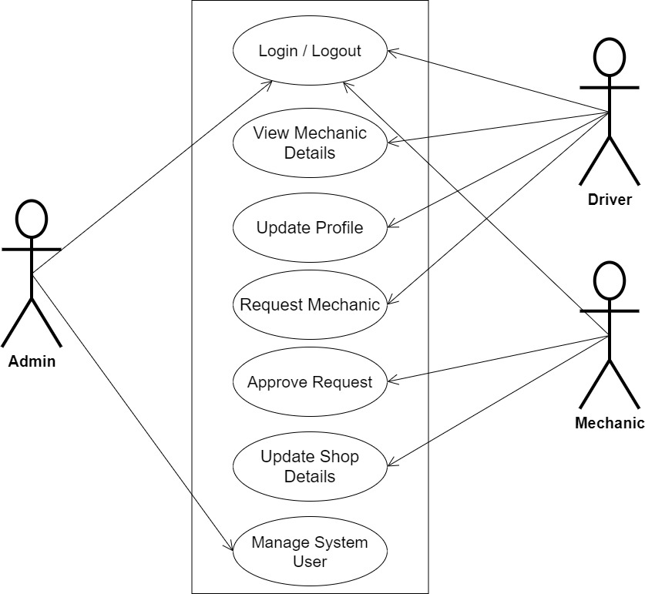Use-case diagrams give a system's high-level operations and domain. These diagrams show how the system's actors interact with one another. Use-case diagrams' use cases and actors describe what the system does and how the actors use it, but they do not explain how the system functions inside.

**Figure 3.1 Use Case**

**3.3.2 Class Diagrams**

The Unified Modeling Language (UML) class diagram is an implementation of an independent perspective of how the system interface would look, with each class having its own set of attributes and demonstrating how they interact with one another. Class diagrams employ the Unified Modeling Language standards to visually portray a given system's static structure and composition (UML).

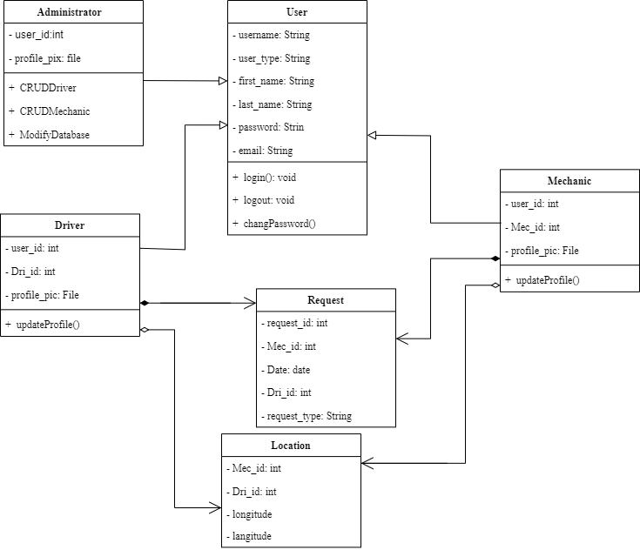

**Figure 3.2 Class Diagram**

**3.3.3 Activity Diagrams**

An activity diagram, like a flowchart or a data flow diagram, visually illustrates a series of events or the flow of control in a system, but it acts more like an enhanced version of both.

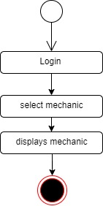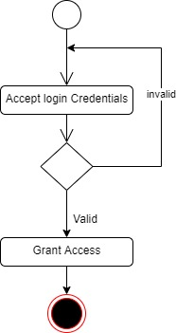

**Figure 3.3 Login Activity Diagram Figure 3.4 View Mechanic Details**

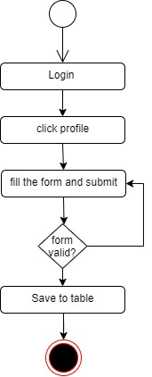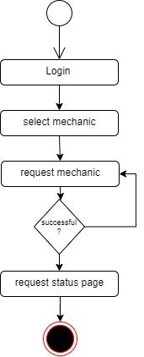

**Figure 3.5 Driver Activity Figure 3.6 Request Mechanic**

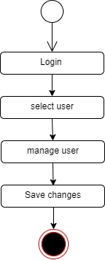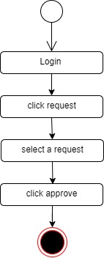

**Figure 3.7 Approve Request Figure 3.8 Update Shop Figure 3.9 Manage User**

**3.4 System Specification**

System specification refers to the detailed and comprehensive description of a computer-based system or software application. It is a critical phase in the system development life cycle and serves as a blueprint for designing, building, and implementing the system. The primary purpose of a system specification is to precisely define what the system is supposed to do, how it should function, and what requirements it needs to meet. (GeeksforGeeks, 2023)

**3.4.1 Input Specification**

The logical explanation of how data is kept in the computer's memory is called input specification. The freedom experienced in using the system, as well as the convenience of retrieving and reading the data and assuring applicability across the internet, make SQL standards essential for ensuring that structured data is uniform and independent of applications. Some of the input specifications employed in this project work are presented below.

**Table 3.1 User Table**

|  |  |  |  |
| --- | --- | --- | --- |
| **FIELD NAME** | **DATATYPE** | **LENGTH** | **KEY** |
| Username | Sting | 8 | Primary key |
| user_type | String | 20 | - |
| first_name | String | 20 | - |
| Last_name | String | 20 | - |
| Pic | String | - | - |
| Password | String | 6 | - |

**Table 3.2 Request Table**

|  |  |  |  |
| --- | --- | --- | --- |
| **FIELDNAME** | **DATATYPE** | **LENGTH** | **KEY** |
| Request_id | int | 8 | Primary Key |
| Mec_id | int | 8 | Foreign Key |
| Dri_id | int | 8 | Foreign Key |
| Date | date | 10 | - |
| Request_type | String | 20 | - |

**Table 3.3 Location Table**

|  |  |  |  |
| --- | --- | --- | --- |
| **FIELD NAME** | **DATATYPE** | **LENGTH** | **KEY** |
| Mec_id | int | 8 | Foreign Key |
| Dri_id | int | 8 | Foreign key |
| Longitude | double | - | - |
| Longitude | double | - | - |

**3.4.2 Output Design**

This shows a visual representation of the system interface it will be made to be intuitive to use, quick to respond to, and visually appealing.

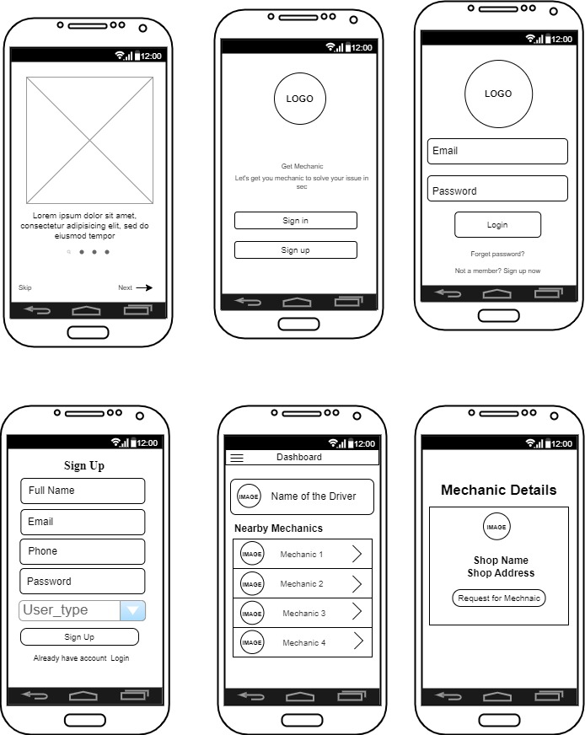***Interface for all users***

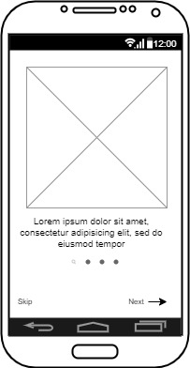

**Figure 3.10 Onboarding Screen Figure 3.11 Landing Page Figure 3.12 Register Page**

***Interface for drivers***





**Fig 3.13 Driver Homepage Fig 3.14 Mechanic Request Page**

***Interface for Mechanic***

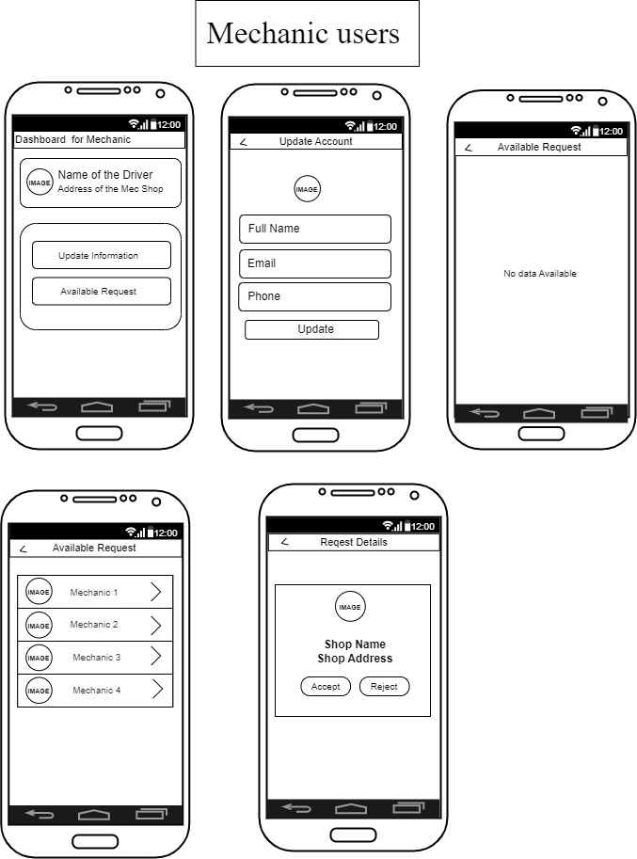

**Figure 3.13 Request Page**

**Figure 3.12 Available Request**

**Figure 3.15 Mechanic Dashboard Figure 3.16 Mechanic Update Page**



**Figure 3.17 Available Request Figure 3.18 Request Details**

**3.7 System Requirement**

Every piece of software generated has predefined system requirements that it must fulfill in order to function properly. The system requirements, on the other hand, are the bare minimum of hardware and software required for the system's intended operation.

**3.7.1 Hardware Requirement**

System Hardware Requirement Include:

1. Minimum of 8 GB of RAM (Random Access Memory) installed.
2. Minimum of intel core i3 processor.
3. Minimum of 250GB HDD (Hard Disk Drive).

**3.7.2 Software Requirement**

The software requirements include:

1. At least windows 10 OS (Operating System).
2. Flutter Installation.
3. Vs. Code / Android studio installation.
4. Emulator installation.

**3.8 Choice of Programming Language**

This research work will be a mobile-based application where flutter will be employed in designing the front-end; SQLite will be used as the database, Django will be used as the backend, Django REST Framework as the web API, Geocoding is used to get the distance between two point. The combination of the above will help build a very robust platform that will be useful, fast, and handy.

**CHAPTER FOUR**

**SYSTEM IMPLEMENTATION AND EVALUATION**

**4.1 Introduction**

In this chapter we focus on testing and develop the mobile app for on road vehicle breakdown assistance. This chapter involve the program; sample output and steps for system installation, to guide new users on how to perform task on the system, to ensure the functionality, accuracy and reliability of the app and validate it usefulness in detecting the nearness mechanics for the driver and also reduce stress of looking for mechanics for drivers when their car breakdown.

**4.2 System Testing Evaluation**

Conducting test for the developed system is more important, because is the only way to confirm that each interface of the app is working perfectly or to analyze problem in it and provide solutions to the problems. This project engaged both unit and integration testing to ensure effectiveness and productivity of design and to ensure that the project is working smoothly and is error-free. They are two ways in doing it which are unit testing and integration testing.

**i. Unit Testing**

In this part, every interface of the app is tested independently to ensure they are working effectively without errors. This section allows the users to verify the functionality of different modules of the app.

**ii. Integration Testing**

This part focuses mostly on the interaction between different components and modules of the mobile app. It combines the individual units tested in the previous part together, where the goal is to identify any inconsistencies or issues that may arise when different modules interact with each other.

**4.3 System Conversion Plan**

The system change plan of approach for transitioning from the existing system to the newly developed mobile app for road vehicle breakdown assistance detection. This section presents different approaches to system conversion, such as the pilot approach, parallel approach, and direct changeover. Each approach's advantages, disadvantages, and considerations are discussed to determine the most suitable plan for implementing the mobile app in a real world.

**4.4 System Installation**

Every system that wants to install the application needs to follow the required steps to be able to install the application and run it smoothly.

1. Open the project folder on Visual Studio Code, then select where you want to build the app either emulator/or phone.
2. Click on Run and select Start debugging to build the app.
3. Connect to any hotspot then open your Command Prompt and type in “ipconfig” to get the hotspot IP address.
4. Activate your virtual environment and runserver using the connected Ip address. For example “py manage.py runserver 192.168.136.227:8000”

**4.5 Security Measures**

Since the scope of the mobile app is public, some of the information such as login, register are available to anyone who visits the app. But some other information and functionalities are restricted to some, which means the driver pages are different from the mechanics page and the activities carried out or perform are different. This restriction are carried out when register on the mobile app, the user will specified if he/she is a mechanic or driver to determine the kind of activity the user will carry out on the app.

**4.6 Program Sample Outputs**

These describe and give the pictorial representation of the software it shows and gives clear understanding of the design, and displays all the interfaces.

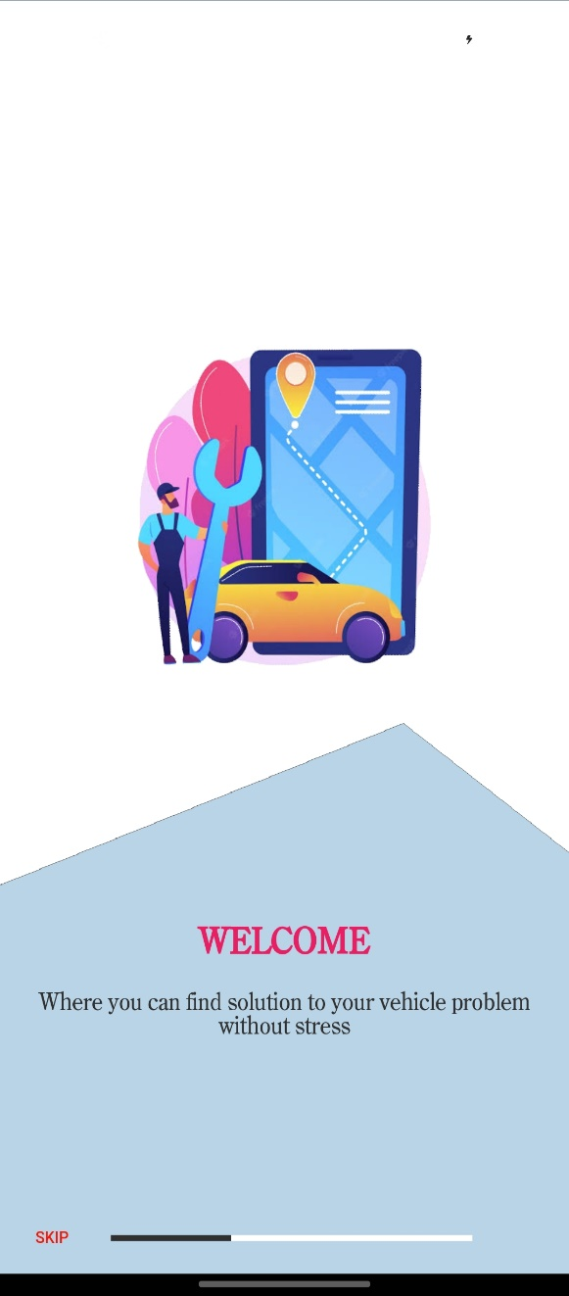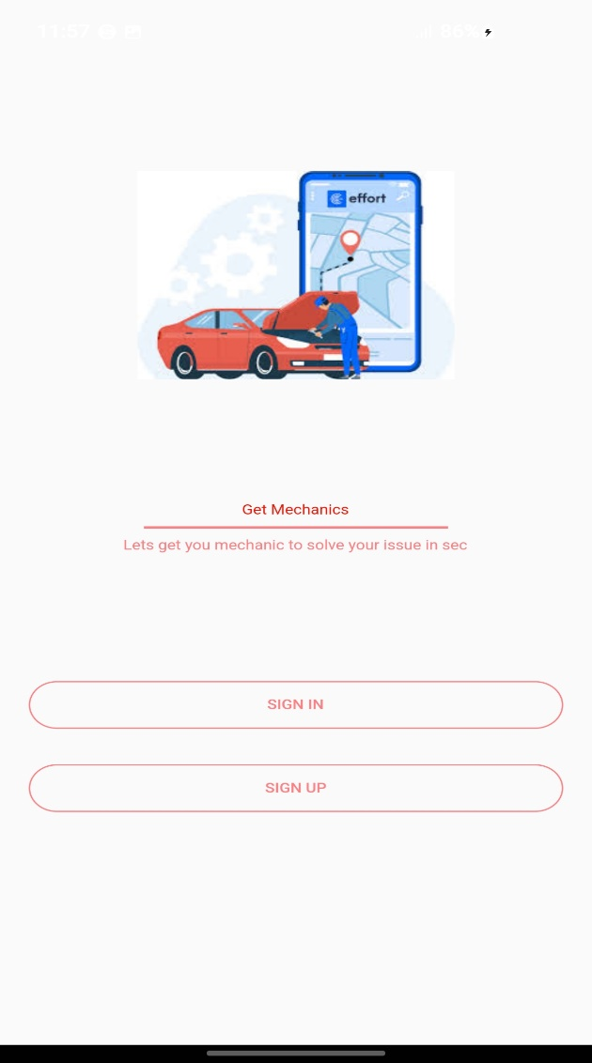

**Figure 4.1 Onboarding Screen Figure 4.2 Landing Screen**

Figure 4.1 Onboarding Screen is the page that will appear for each first time users, the screen depits what the application is all about

Figure 4.2 Landing Screen is the next screen that it will take the user after the onboarding, where the user can select to login or create an account.

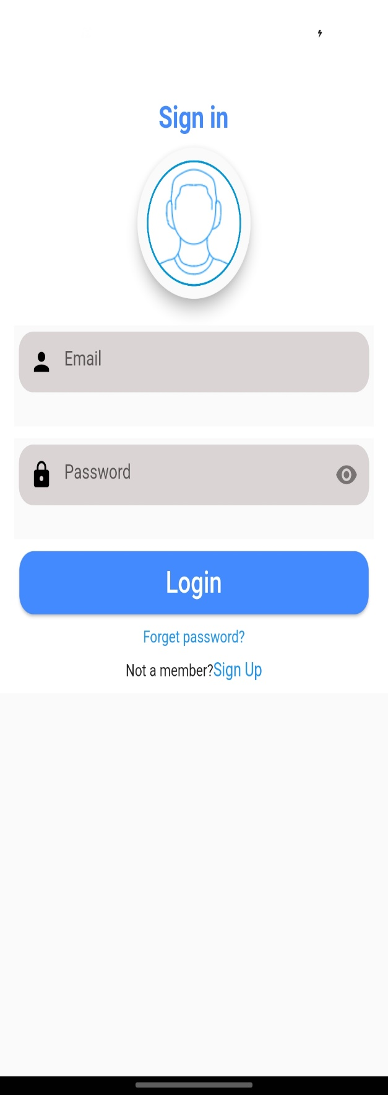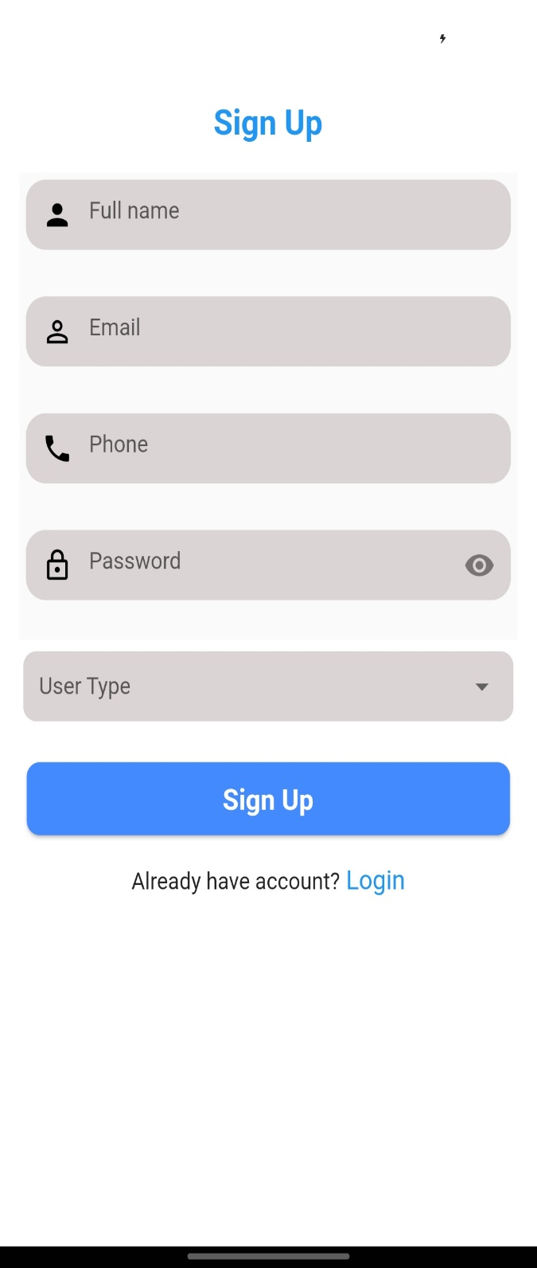

**Figure 4.3 Register Screen Figure 4.4 Login Screen**

Figure 4.3 Register Screen: this is the page that every user will visit before authentication, the page helps the system to decide what kind of user is making use of the system.

*Fig: 4.6.3 Login Page*

Figure 4.4 Login Screen: this is the page that will appear immediately after a user registers, but only for users that have created an account before.

**Output for Mechanic Users**

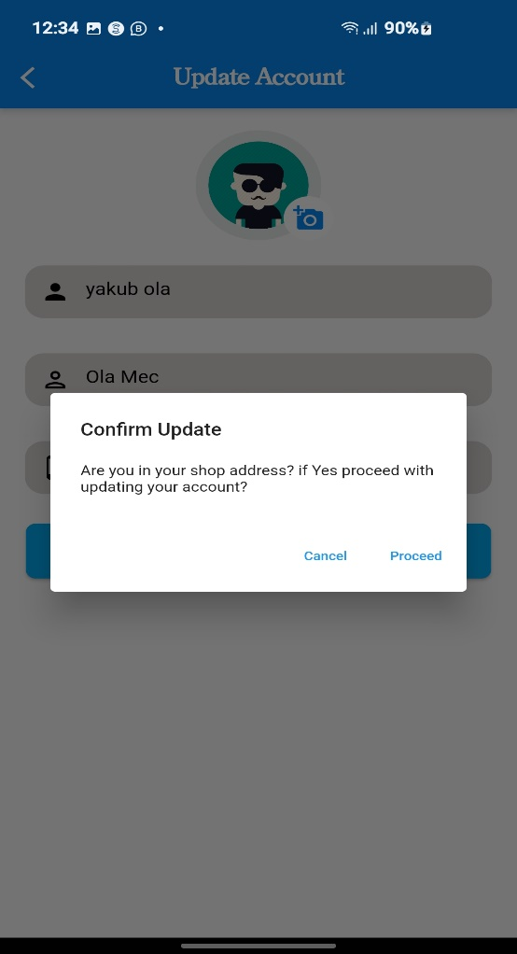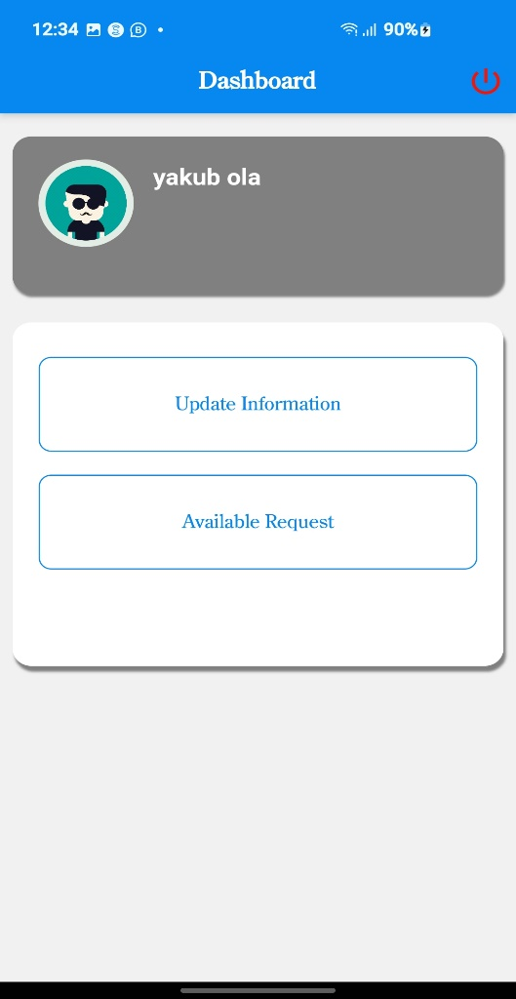

**Figure 4.5 Mechanic Dashboard Figure 4.6 Mechanic Profile Screen**

Figure 4.5 Mechanic Dashboard is the page that appears if the current logged in user is of type mechanic, which present two options, to update profile information as well as view available request.

Figure 4.6 Mechanic Profile Screen, provide the opportunity for mechanic to update their shop location, profile picture and basic information.

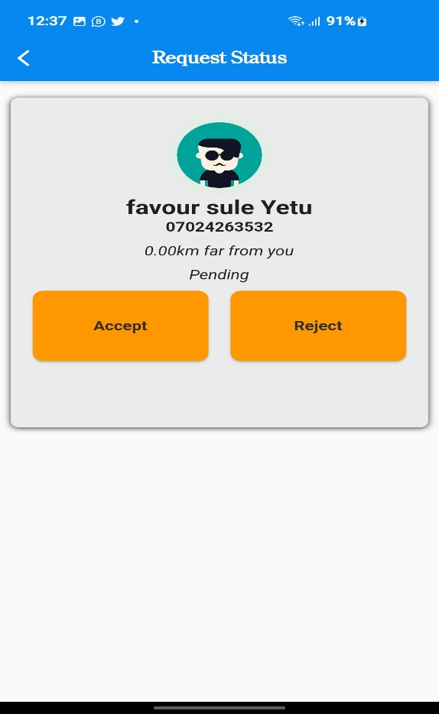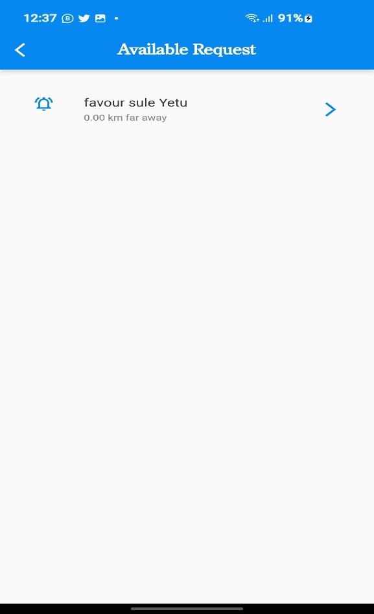

**Figure 4.7 Available Request Figure 4.8 Request Status**

Figure 4.7 Available Request Screen, this is the screen where every request sent to the mechanic from different driver will appear, the mechanic can now select which one he/she want to attend to.

Figure 4.8 Request Status Page this screen that will show immediately the mechanic click on one of the request to either accept or reject the request.

**Output for Drivers**

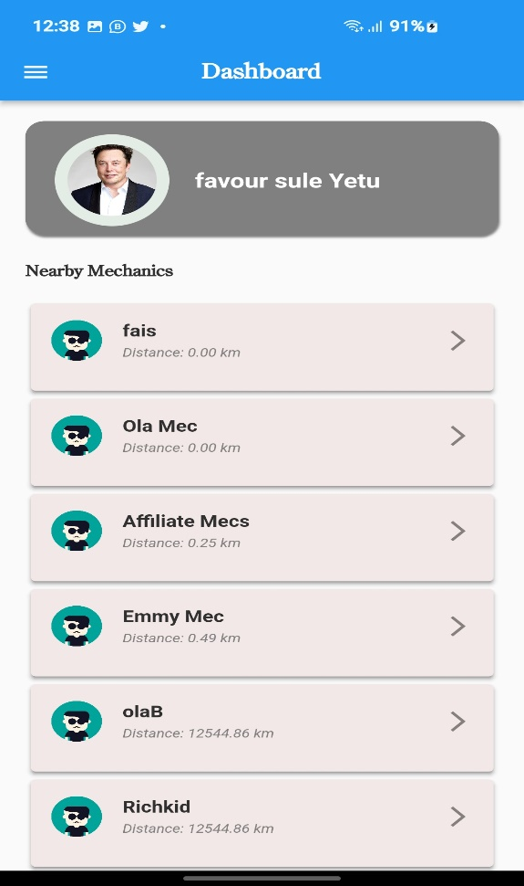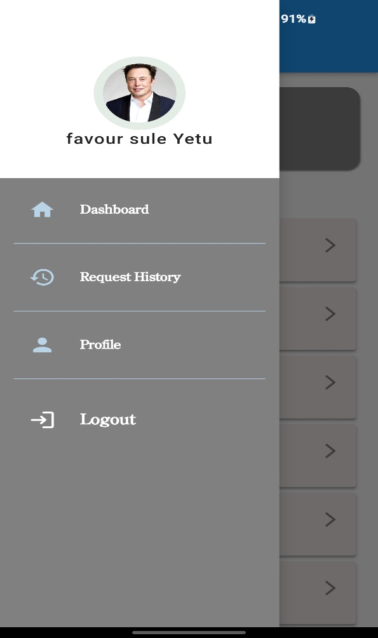

**Figure 4.9 Driver Dashboard Figure 4.10 Driver Sidebar**

Figure 4.9 Driver Dashboard is a screen for each driver that displays all the nearby mechanic based on the distance from the driver location.

Fig 4.10 Driver Sidebar screen shows all the functionalities available for the driver for their easy navigation.

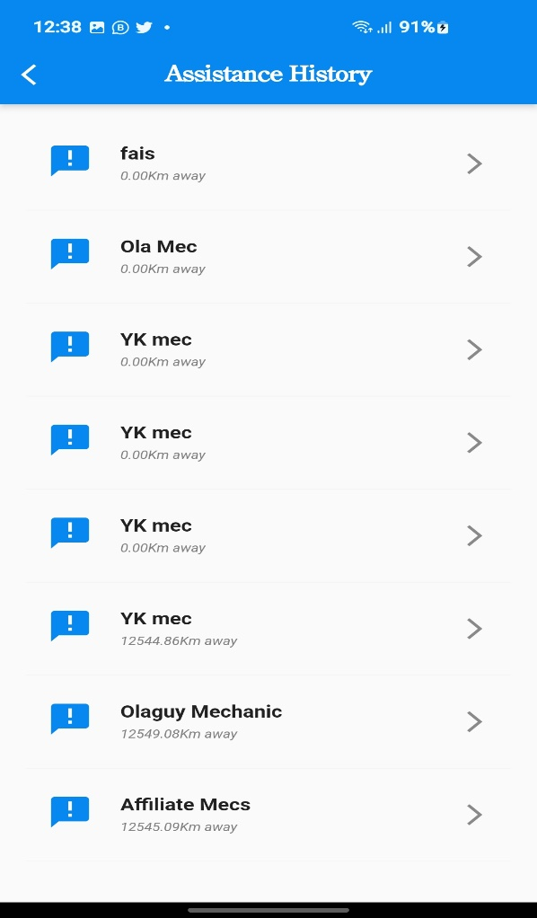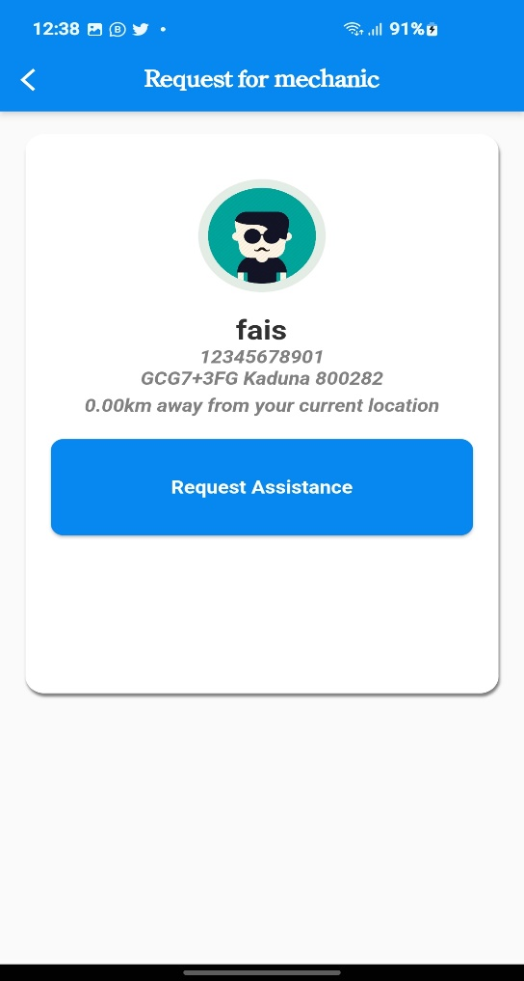

**Figure 4.11 Request Assistance Figure 4.12 Assistance History**

Fig 4.6.11 Request Assistance screen shows immediately this driver select one mechanic to request for their service, the screen carries the contact information of the mechanic.

Fig 4.6.12 Assistance History screen displays all the request the driver has made to different mechanics.

**CHAPTER FIVE**

**SUMMARY, CONCLUSION AND RECOMMENDATION**

**5.1 Summary**

This project focus on the implementation of on road vehicle breakdown assistance. This system is proposed in order to provide assistance for drivers to locate mechanics easily without stress and also help mechanic to find new customers. With the implementation of the system drivers will not be going through much stress to locate driver anywhere anytime.

**5.2 Recommendations**

When it comes to road vehicle breakdown assistance, there are several things that can offer as services. Here are a few recommendations:

1. Adding online payment to the project so that the driver can easily go for the payment price that is suitable for him or her.
2. When choosing a breakdown assistance provider, consider factors like coverage options, service quality, response times, pricing, and the provider's network coverage in your area. It can also be helpful to read customer reviews and compare the features and benefits of different providers to find the one that best meets your specific needs.

**5.3 Conclusion**

Road vehicle breakdown assistance plays a crucial role in ensuring the safety, convenience, and peace of mind to motorists. Based on the information available the system provides reliable support to motorists experiencing mechanical failures, or other emergencies. It offers timely response and aim to minimize disruptions in transportation and aim to alleviate this stress by providing a convenient and reliable solution. Knowing that help is just a phone call away can give drivers peace of mind, especially when traveling in unfamiliar areas.

**REFERENCES**

Bhandari, P. (2023). Data Collection | Definition, Methods & Examples. *Scribbr*. https://www.scribbr.com/methodology/data-collection/

Fai, L. W., & Audah, L. (2017). In campus location finder using mobile application services. AIP Conference Proceedings, 1883. <https://doi.org/10.1063/1.5002040>

GeeksforGeeks. (2023). What is System Design  Learn System Design. *GeeksforGeeks*. https://www.geeksforgeeks.org/what-is-system-design-learn-system-design/

Nevon Projects. (2021, August 13). Web-Based Place Finder Using Django Python. https://nevonprojects.com/web-based-place-finder-using-django-and-geodjango/

Nadeeshani, I. H. (2020). On-Road Vehicle Breakdown Assistance. https://doi.org/10.13140/RG.2.2.11833.39521

Olufemi, A. N., & Sah, M. (2022). Location Finder Mobile Application Using Android and Google Spreadsheets. In Smart Innovation, Systems and Technologies, 237, 723–736. https://doi.org/10.1007/978-981-16-3637-0_51

Wibowo, K. M., Kanedi, I., & Jumadi, J. (2018). Sistem Informasi Berbasis Web Dengan Php Dan Mysql. J. Media Infotama, 11(1), 51–60.

Wei Chuan, L., Kasim, S., Choon Sen, S., Hassan, R., & Mohd. Ali, N. (2017). Batu Pahat Car Workshops Finder. *International Journal of Innovative Computing, 7*(2). https://doi.org/10.11113/ijic.v7n2.146

**APPENDIX**

**Views.py**

from django.shortcuts import render

from rest_framework import generics

from rest_framework.generics import GenericAPIView

from rest_framework import status

from rest_framework import permissions

from rest_framework.response import Response

from rest_framework.views import APIView

from django.views import View

from RD_auth.models import RequestMec

from RD_auth.serializer import *

# Create your views here.

class RegisterView(generics.CreateAPIView):

    """This View create an account for the user"""

    serializer_class = RegisterSerializer

    permission_classes = [permissions.AllowAny]

    def create(self, request, *args, **kwargs):

        """Creates a user"""

        super().create(request, *args, **kwargs)

        return Response(status=status.HTTP_201_CREATED)

class UserView(generics.RetrieveAPIView):

    """This view returns a user"""

    serializer_class = UserSerializer

    permission_classes = (permissions.IsAuthenticated,)

    def get_object(self):

        return self.request.user

class UpdateUserView(generics.UpdateAPIView):

    """This view returns a user"""

    serializer_class = EditUserSerializer

    queryset = User.objects.all()

    permission_classes = (permissions.IsAuthenticated,)

class GetMechanicsView(APIView):

    """This view gets all mechanics from a user"""

    # serializer_class = AllMecSerializers

    permission_classes = (permissions.IsAuthenticated,)

    def get(self, request, *args, **kwargs):

        mechanics = User.objects.filter(is_mec=True, shop_address__isnull=False)

        serializer = AllMecSerializers(mechanics, context={'geo_data':request.data}, many=True)

        ordered_serializer_data = sorted(serializer.data, key=lambda x: x['distance'])

        return Response(ordered_serializer_data)

class GetAMecView(generics.RetrieveAPIView):

    """This view returns a mechanic"""

    serializer_class = AllMecSerializers

    permission_classes = (permissions.IsAuthenticated,)

    def get(self, request, pk):

        try:

            mechanic = User.objects.get(user_id=pk)

            serializers = AllMecSerializers(mechanic, context={'geo_data':request.data})

            return Response(serializers.data)

        except User.DoesNotExist :

            return Response(status = status.HTTP_400_BAD_REQUEST)

class RequestAMecView(generics.CreateAPIView):

    """Driver can request for a mec"""

    serializer_class = RequestAMecSerializer

    permission_classes = [permissions.IsAuthenticated]

class VerifyPendingRequestView(APIView):

    """This view verifies if the driver has any pending request"""

    permission_classes = (permissions.IsAuthenticated,)

    def get(self, request, *args, **kwargs):

        driver_id = request.data

        assistance = RequestMec.objects.filter(approved=False, pending=True, driver_id=driver_id['driver_id'])

        if assistance:

            return Response(status = status.HTTP_400_BAD_REQUEST)

        return Response(status = status.HTTP_200_OK)

**Main.dart**

import 'package:flutter/material.dart';

import 'package:welcome/controllers/getMecController.dart';

import 'package:welcome/controllers/getNearbyMecController.dart';

import 'package:welcome/controllers/profile_controller.dart';

import 'package:welcome/models/nearby_mec.dart';

import 'package:welcome/utils/constant.dart';

import 'package:get/get.dart';

class DriverHome extends StatefulWidget {

  const DriverHome({super.key});

  @override

  State<DriverHome> createState() => _DriverHomeState();

}

class _DriverHomeState extends State<DriverHome> {

  ProfileController profileController = Get.put(ProfileController());

  GetNearbyMecController getNearbyMecController =

      Get.put(GetNearbyMecController());

  GetMecController getMecController = Get.put(GetMecController());

  @override

  Widget build(BuildContext context) {

    final size = MediaQuery.of(context).size;

    return WillPopScope(

            onWillPop: () async {

        showDialog(

          context: context,

          builder: (context) {

            return AlertDialog(

              title: const Text('Confirm Logout'),

              content: const Text('Are you sure you want to logout?'),

              actions: [

                TextButton(

                  onPressed: () {

                    Navigator.pop(context);

                  },

                  child: const Text('Cancel'),

                ),

                TextButton(

                  onPressed: () async {

                    Navigator.pop(context);

                    Get.back();

                  },

                  child: const Text('Logout'),

                ),

              ],

            );

          },

        );

        return true;

      },

      child: Scaffold(

        appBar: AppBar(

          title: const Text(

            'Dashboard',

            style: TextStyle(fontWeight: FontWeight.bold, color: kDarkColor),

          ),

          centerTitle: true,

          // backgroundColor: kWhiteColor,

        ),

        body: RefreshIndicator(

          onRefresh: () => getNearbyMecController.getNearbyMechanic(),

          child: SingleChildScrollView(

            child: Padding(

              padding: const EdgeInsets.symmetric(horizontal: 20.0, vertical: 20),

              child: Column(

                mainAxisAlignment: MainAxisAlignment.start,

                crossAxisAlignment: CrossAxisAlignment.start,

                children: [

                  Container(

                    height: size.height * .13,

                    width: size.width,

                    margin: const EdgeInsets.only(bottom: 10),

                    decoration: BoxDecoration(

                      borderRadius: BorderRadius.circular(15),

                      color: kWhiteColor,

                      boxShadow: const [

                        BoxShadow(

                            color: kLightColor,

                            blurRadius: 1.0,

                            offset: Offset(1, 3)),

                      ],

                    ),

                    padding: const EdgeInsets.only(top: 05.0, left: 10),

                    child: Obx(

                      () => profileController.isLoading.value

                          ? const Center(child: CircularProgressIndicator())

                          : Row(

                              crossAxisAlignment: CrossAxisAlignment.center,

                              children: [

                                Padding(

                                  padding: const EdgeInsets.only(

                                      left: 8.0, top: 8, bottom: 8),

                                  child: CircleAvatar(

                                    backgroundColor:

                                        const Color.fromARGB(255, 228, 236, 230),

                                    maxRadius: 50,

                                    minRadius: 50,

                                    child: ClipOval(

                                      child: Image.memory(

                                        profileController.userProfile!.image,

                                        height: 70,

                                        width: 70,

                                        fit: BoxFit.cover,

                                        // alignment: Alignment.topRight,

                                      ),

                                    ),

                                  ),

                                ),

                                const SizedBox(

                                  width: 15,

                                ),

                                Text(

                                  profileController.userProfile!.name,

                                  softWrap: true,

                                  style: const TextStyle(

                                      fontSize: 22,

                                      fontFamily: 'Schyuler',

                                      fontWeight: FontWeight.bold),

                                ),

                              ],

                            ),

                    ),

                  ),

                  const Padding(

                    padding: EdgeInsets.symmetric(vertical: 20.0),

                    child: Text(

                      'Nearby Mechanics',

                      style: TextStyle(

                        fontSize: 18.0,

                        fontFamily: 'Schuyler',

                        fontWeight: FontWeight.bold,

                        color: kDarkColor,

                      ),

                    ),

                  }